So Ole Says to Lena: Folk Humor of the Upper Midwest
Compiled and edited by James P. Leary
Published by University of Wisconsin Press

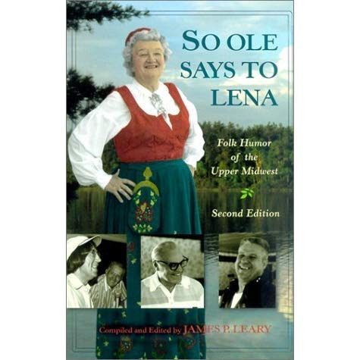
In the land of beer, cheese, and muskies—where the polka is danced and winter is unending and where Lutherans and Catholics predominate—everybody is ethnic, the politics are clean, and the humor is plentiful. This collection includes jokes, humorous anecdotes, and tall tales from ethnic groups (Woodland Indians, French, Cornish, Germans, Irish, Scandinavians, Finns, and Poles) and working folk (loggers, miners, farmers, townsfolk, hunters, and fishers). Dig into the rich cultural context supplied by the notes and photographs, or just laugh at the hundreds of jokes gathered at small-town cafes, farm tables, job sites, and church suppers. This second edition includes an afterword and indexes of motifs and tale types.

“A treasure trove of ‘occupational humor’ that’s often slightly racy and usually shot through with a blunt appreciation of the peculiar ways of the Midwestern world.”
—Tom Laskin, Isthmus
“A funny book, but no mere joke book.”
—The Country Today

James P. Leary is a Fellow of the Wisconsin Academy for Sciences, Arts, and Letters, and an emeritus professor of Folklore and Scandinavian Studies at the University of Wisconsin–Madison, where he co-founded the Center for the Study of Upper Midwestern Cultures. A two-time Grammy nominee for Best Album Notes, his books include Folksongs of Another America: Field Recordings from the Upper Midwest, 1937-1946; Polkabilly: How the Goose Island Ramblers Redefined American Folk Music, Wisconsin Folklore, Yodeling in Dairyland: A History of Swiss Music in Wisconsin, and Down Home Dairyland, with Richard March.

